Scrum
Scrum is a framework for project management that emphasizes teamwork, accountability and iterative progress toward a well-defined goal.
- Three phases in Scrum:
An outline planning for the project and design the software architecture.
A series of sprint cycles, where each cycle develops an increment of the system.
The project closure phase wraps up the project, completes required documentation.
The Scrum process:
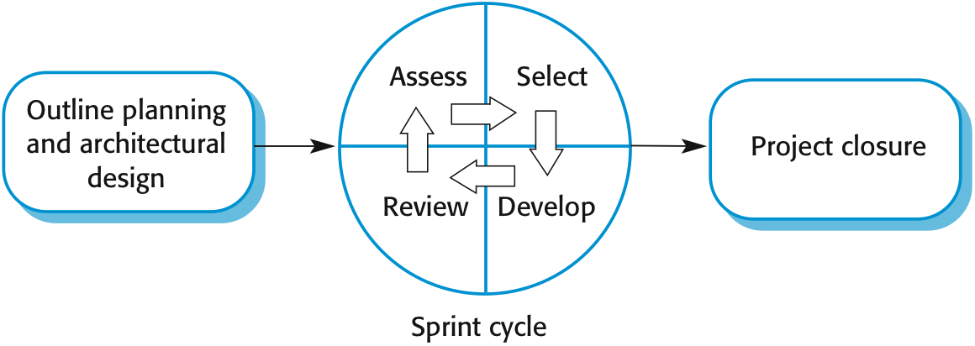
A Scrum sprint cycle is a timeboxed period when a team delivers a set amount of work. It includes task planning, performing, managing the tasks, attending daily stand-ups, and communicating with the Scrum teams. The outcome of Sprint Execution is a potentially shippable product increment, formed from a list of product backlog items by meeting the team members' definition of done.
Teamwork in Scrum:
A scrum team is a group of collaborators, typically between five and nine individuals, who work toward completing projects and delivering products. The fundamental scrum team comprises one scrum master, one product owner and a group of developers. Within a scrum team, there is no rank or hierarchy.
Advantage and Disadvantage:
Advantage | Disadvantage
1. Motivated to finish the sprint. | 1. Losing the track of the process.
2. All team-members have the access to project progress. | 2. Not clear defining each role.
3. The focus on quality. | 3. No big picture of the project.
4. Easy to recognize.

